**5. System Models**

**5.1 Use case model**

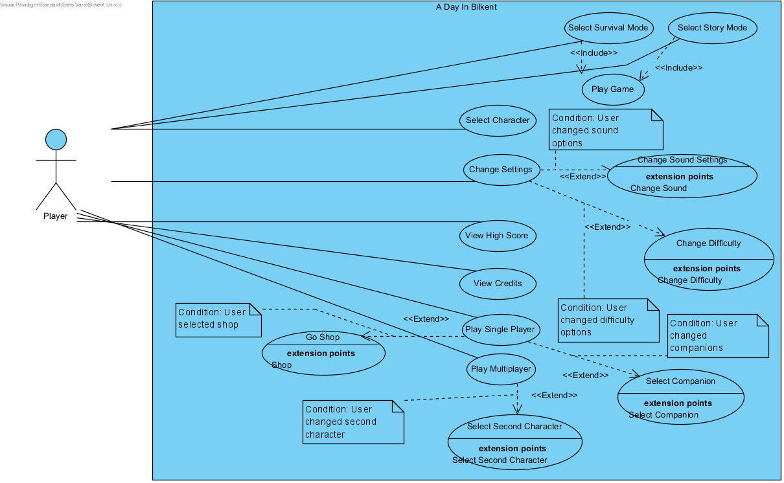

**Use Case: Select Survival Mode**

**Primary Actor**: Player

**Stakeholders and Interests:**

* Player selects survival mode.
* System creates the game and starts it.

**Pre-conditions:** Player must be in main menu.

**Post-conditions:**

**Entry conditions:** Player should select "Play Survival" from screen.

**Exit conditions:**

1. Player and his friend finishes the story mode.
2. Player and his friend can’t finish the story mode.

**Success Scenario Event Flow:**

1. Player selects "Play Survival" from game screen.

2. System starts the game.

3.Player moves the character via keyboard.

4.System updates character’s view.

5. Player’s friend moves the character via keyboard.

6. System updates character’s view.

7.Characters shoots.

8.System creates bullets and updates it.

9.Bullets hit an enemy.

10.System deallocates bullet and enemy and removes from screen.

11.Player kills all enemies.

12.System finishes the first wave and initializes the next wave.

**Alternative Event Flow:**

1. If Player want to return to main menu:

a. Player selects "Go Back" from screen.

**Use Case: Select Story Mode**

**Primary Actor**: Player

**Stakeholders and Interests:**

* Player selects play story mode.
* System creates the game and starts it.

**Pre-conditions:** Player must be in main menu.

**Post-conditions:**

**Entry conditions:** Player should select "Play Story " from screen.

**Exit conditions:**

1. Player finishes the story mode.
2. Player can’t finish the story mode.

**Success Scenario Event Flow:**

1. Player selects “Play Story” from screen.

2. System starts the game.

3.Player moves the character and companions via keyboard.

4.System updates character and companions’ view.

5.Character and companions shoots.

6.System creates bullets and updates it.

7.Bullets hit an enemy.

8.System deallocates bullet and enemy and removes from screen.

9.Player kills all enemies.

10.System finishes the first level and initializes the next level.

**Alternative Event Flow:**

1. If character dies:

a. System shows “Game Over” screen and goes back to main menu.

**Use Case: Select Character**

**Primary Actor**: Player

**Stakeholders and Interests:**

* Player selects select character.
* System creates the select character screen and displays it.

**Pre-conditions:** Player must be in main menu.

**Post-conditions:**

**Entry conditions:** Player should select "Select Character" from screen.

**Exit conditions:**

1. Player selects “Go Back” from screen.

**Success Scenario Event Flow:**

1. Player selects “Select Character” from screen.

2. System creates the select character screen and displays it.

3.Player selects his character.

4.System updates character information.

**Alternative Event Flow:**

1. If Player wants to go back to main menu:

a. Player selects “Go Back” from screen.

b. System creates main menu and displays it.

**Use Case: Change Settings**

**Primary Actor**: Player

**Stakeholders and Interests:**

* Player selects settings.
* System creates the settings screen and displays it.

**Pre-conditions:** Player must be in main menu.

**Post-conditions:**

**Entry conditions:** Player should select "Settings" from screen.

**Exit conditions:**

1.Player selects “Go Back” from screen.

**Success Scenario Event Flow:**

1. Player selects “Settings” from screen.

2. System creates the settings screen and displays it.

3.Player changes sound and difficulty settings.

4.System updates sound and difficulty information.

**Alternative Event Flow:**

1. If Player wants to go back to main menu:

a. Player selects “Go Back” from screen.

b. System creates main menu and displays it.

**Use Case: View High Score**

**Primary Actor**: Player

**Stakeholders and Interests:**

* Player selects high scores.
* System creates the high scores screen and displays it.

**Pre-conditions:** Player must be in main menu.

**Post-conditions:**

**Entry conditions:** Player should select "High Scores" from screen.

**Exit conditions:**

1.Player selects “Go Back” from screen.

**Success Scenario Event Flow:**

1. Player selects “High Scores” from screen.

2. System gets high score information.

3. System creates the high scores screen and displays it.

**Alternative Event Flow:**

1. If Player wants to go back to main menu:

a. Player selects “Go Back” from screen.

b. System creates main menu and displays it.

**Use Case: View Credits**

**Primary Actor**: Player

**Stakeholders and Interests:**

* Player selects view credits.
* System creates the credits screen and displays it.

**Pre-conditions:** Player must be in main menu.

**Post-conditions:**

**Entry conditions:** Player should select "Credits" from screen.

**Exit conditions:**

1.Player selects “Go Back” from screen.

**Success Scenario Event Flow:**

1. Player selects “Credits” from screen.

2. System creates the credits screen and displays it.

**Alternative Event Flow:**

1. If Player wants to go back to main menu:

a. Player selects “Go Back” from screen.

b. System creates main menu and displays it.

**Use Case: Play Single Player**

**Primary Actor**: Player

**Stakeholders and Interests:**

* Player selects single player mode.
* System updates the main menu components and shows on the screen.

**Pre-conditions:** Player must open the game from his computer.

**Post-conditions:**

**Entry conditions:** Player should select "Single Player" from screen.

**Exit conditions:**

1. Player selects "Multiplayer" from screen.
2. Player quits the game.

**Success Scenario Event Flow:**

1. Player selects "Single Player" from game screen.

2. System updates the main menu components and displays it on screen.

**Alternative Event Flow:**

1. If Player want to return to multiplayer:

a. Player selects "Multiplayer" from screen.

**Use Case: Play Multiplayer**

**Primary Actor**: Player

**Stakeholders and Interests:**

* Player selects multiplayer mode.
* System updates the main menu components and shows on the screen.

**Pre-conditions:** Player must open the game from his computer.

**Post-conditions:**

**Entry conditions:** Player should select "Multi Player" from screen.

**Exit conditions:**

1.Player selects "Single Player" from screen.

2.Player quits the game.

**Success Scenario Event Flow:**

1. Player selects "Multiplayer" from game screen.

2. System updates the main menu components and displays it on screen.

**Alternative Event Flow:**

1. If Player want to return to multiplayer:

a. Player selects "Single Player" from screen.

**Use Case: Select Second Character**

**Primary Actor**: Player

**Stakeholders and Interests:**

* Player selects select second character.
* System creates the select second character screen and displays it.

**Pre-conditions:** Player must select Multiplayer mode.

**Post-conditions:**

**Entry conditions:** Player should select "Select Second Character" from screen.

**Exit conditions:**

1. Player selects “Go Back” from screen.

**Success Scenario Event Flow:**

1. Player selects "Multiplayer" from game screen.

2. System updates the main menu components and displays it on screen.

3. Player selects “Select Second Character” from screen.

4. System creates the select second character screen and displays it.

5.Player selects second character.

6.System updates second character information.

**Alternative Event Flow:**

1. If Player wants to go back to main menu:

a. Player selects “Go Back” from screen.

b. System creates main menu and displays it.

**Use Case: Select Companion**

**Primary Actor**: Player

**Stakeholders and Interests:**

* Player selects select companion.
* System creates the select companion screen and displays it.

**Pre-conditions:** Player must select Single Player mode.

**Post-conditions:**

**Entry conditions:** Player should select "Select Companion" from screen.

**Exit conditions:**

1. Player selects “Go Back” from screen.

**Success Scenario Event Flow:**

1. Player selects “Single Player” from game screen.

2. System updates the main menu components and displays it on screen.

3. Player selects “Select Companion” from screen.

4. System creates the select companion screen and displays it.

5.Player selects his companions.

6.System updates companion information.

**Alternative Event Flow:**

1. If Player wants to go back to main menu:

a. Player selects “Go Back” from screen.

b. System creates main menu and displays it.

**Use Case: Go Shop**

**Primary Actor**: Player

**Stakeholders and Interests:**

* Player selects shop.
* System creates the shop screen and displays it.

**Pre-conditions:** Player must select Single Player mode.

**Post-conditions:**

**Entry conditions:** Player should select "Shop" from screen.

**Exit conditions:**

1. Player selects “Go Back” from screen.

**Success Scenario Event Flow:**

1. Player selects “Single Player” from main menu.

2. System updates the main menu components and displays it on screen.

3. Player selects “Shop” from screen.

4. System creates the shop screen and displays it.

5.Player buys items.

6.System updates currency and item information.

**Alternative Event Flow:**

1. If Player wants to go back to main menu:

a. Player selects “Go Back” from screen.

b. System creates main menu and displays it.